Rock, paper, scissors



In this project you will make Rock, Paper, Scissors in Scratch.

To have your move, you’ll take a photo of your hand.

But first, you’ll need to train the computer to look at your photos and recognise the different hand shapes of rock, paper, and scissors.

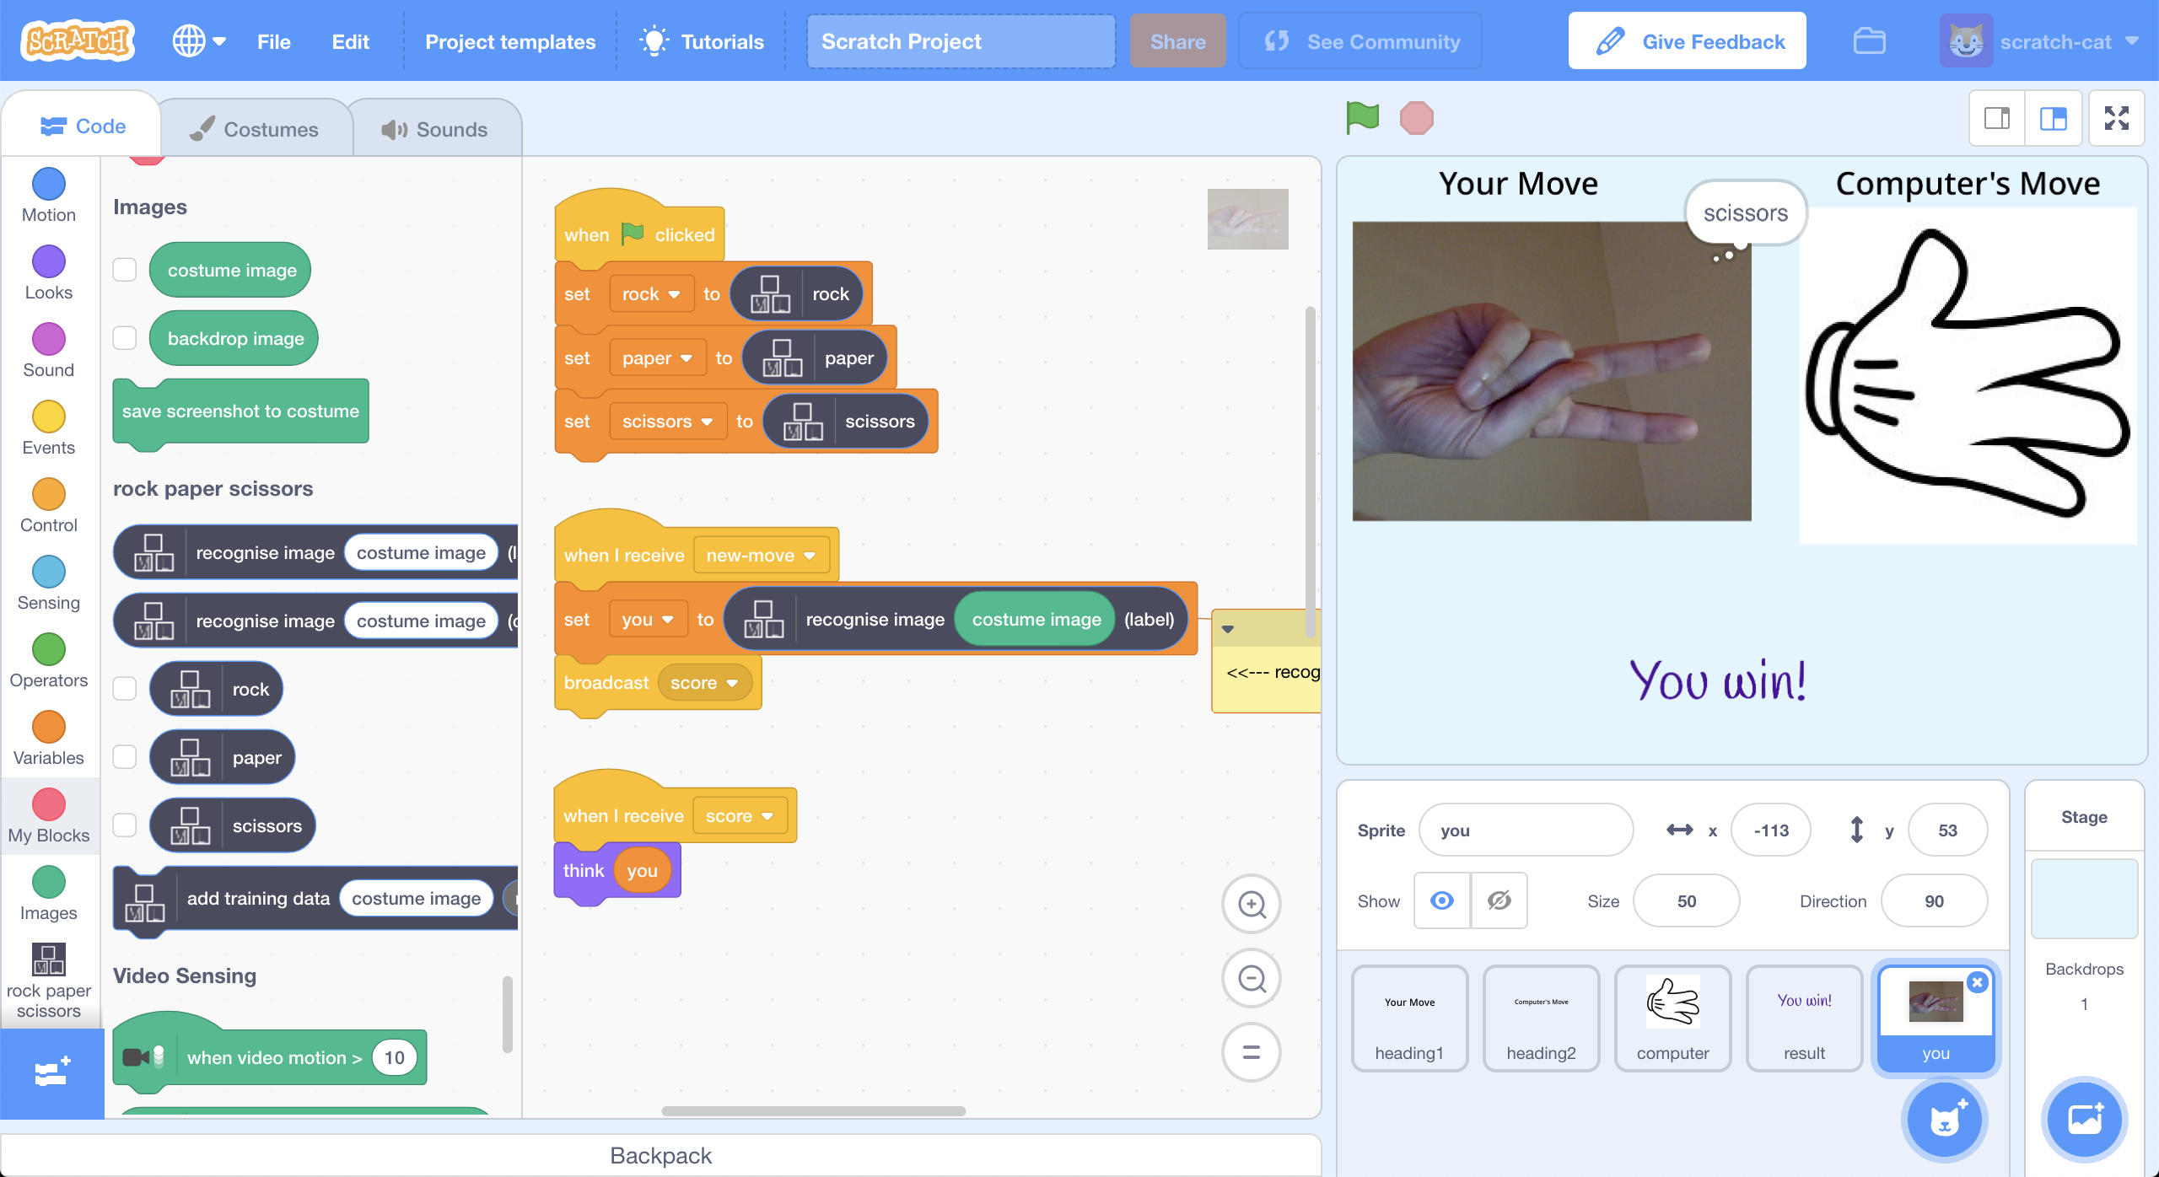

This project worksheet is licensed under a Creative Commons Attribution Non-Commercial Share-Alike License

http://creativecommons.org/licenses/by-nc-sa/4.0/

**This activity will include you taking pictures of your hand & uploading them.**

If you’re not happy with that, ask your teacher or group leader for a different activity.

1. Go to <https://machinelearningforkids.co.uk/> in a web browser
2. Click on “**Get started**”
3. Click on “**Log In**” and type in your username and password  
   *If you don’t have a username, ask your teacher or group leader to create one for you.  
   If you can’t remember your username or password, ask your teacher or group leader to reset it for you.*
4. Click on “**Projects**” on the top menu bar
5. Click the **“+ Add a new project**” button.
6. Name your project “rock paper scissors” and set it to learn how to recognise “**images**”.   
   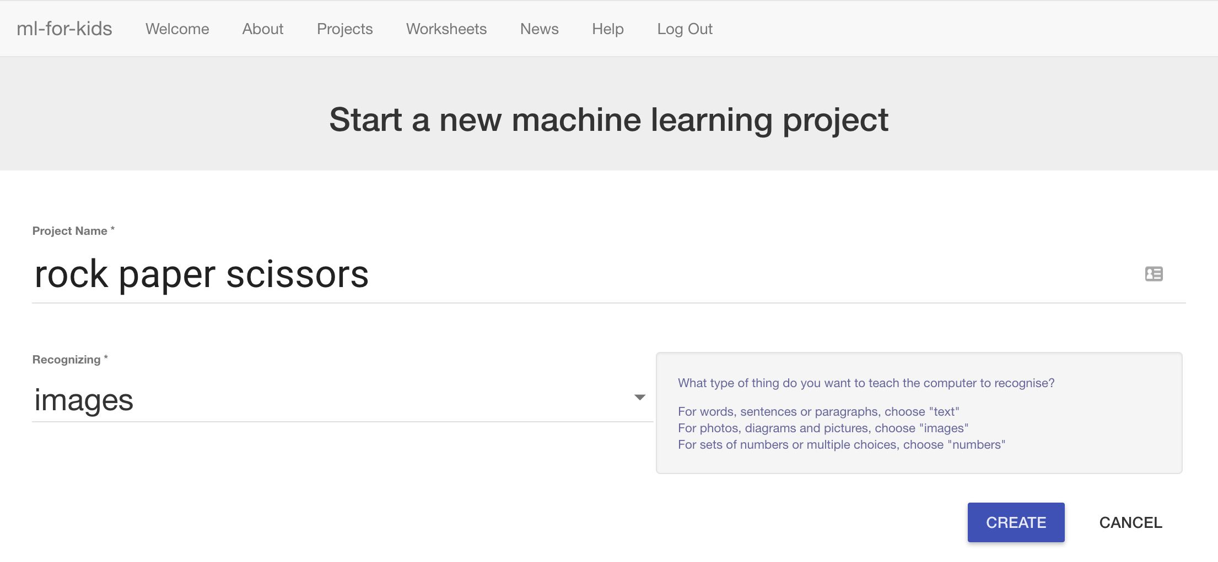
7. Click the “**Create**” button
8. You should see “rock paper scissors” in the projects list. Click on it.  
   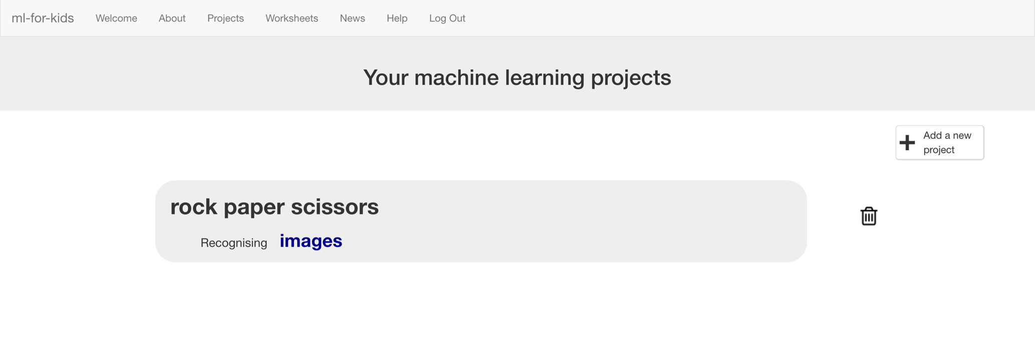
9. Click on “**Train**”  
   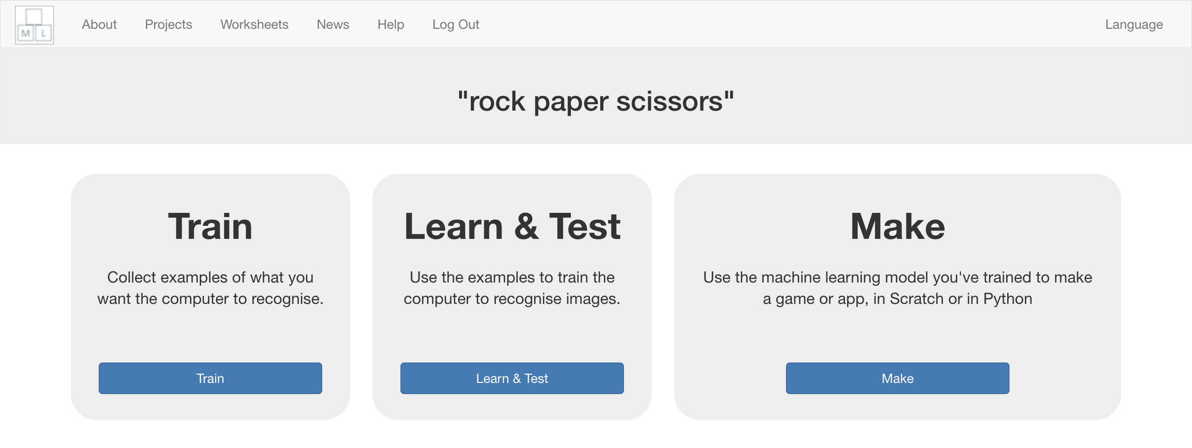
10. Click “**+ Add new label**” and create a bucket called “rock”.  
    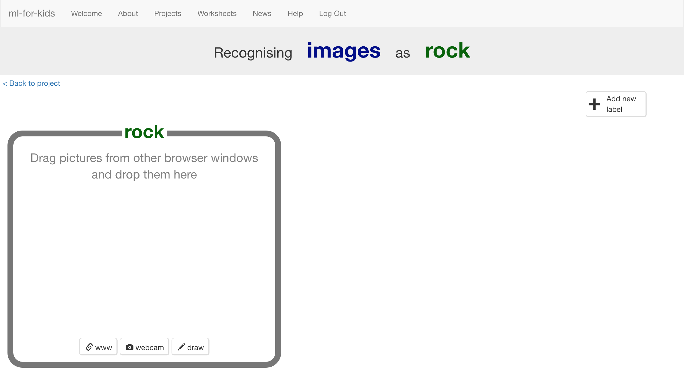
11. Click “**webcam**”

*A Preview window shows the current view from your webcam.*  
*You will need to click “Approve” or “Allow” if your web browser asks permission to use your webcam.*

1. Make your hand into a “rock” shape (fist) in front of the webcam  
   
2. When you’re ready, click “**ADD**” to take a picture  
   *If you’re doing this with a partner, it might be easier for one of you to click on “ADD” while the other makes hand-shapes.*
3. Click “**webcam**” again  
   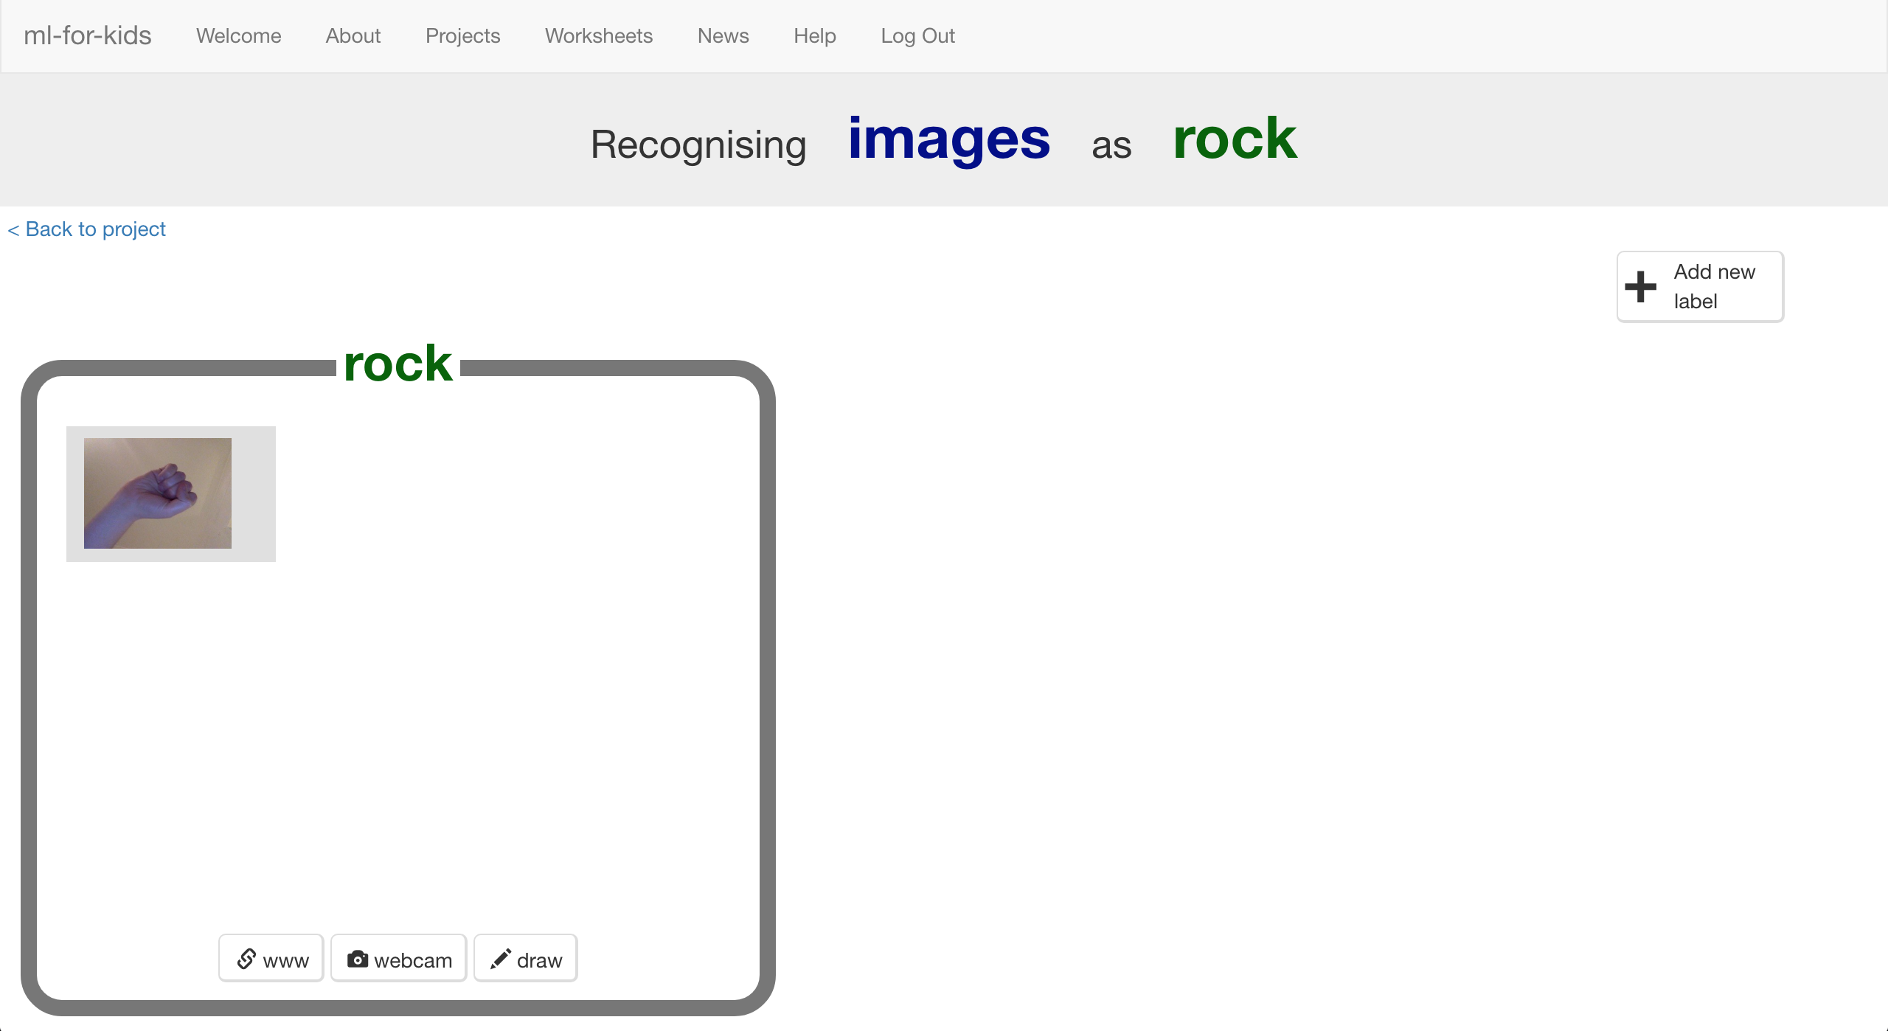
4. Repeat until you’ve got **10** examples of a “rock” shape (fist).   
   *Try to get a variety of positions, angles and sizes.   
   The more variation the computer has to learn from, the better.*  
   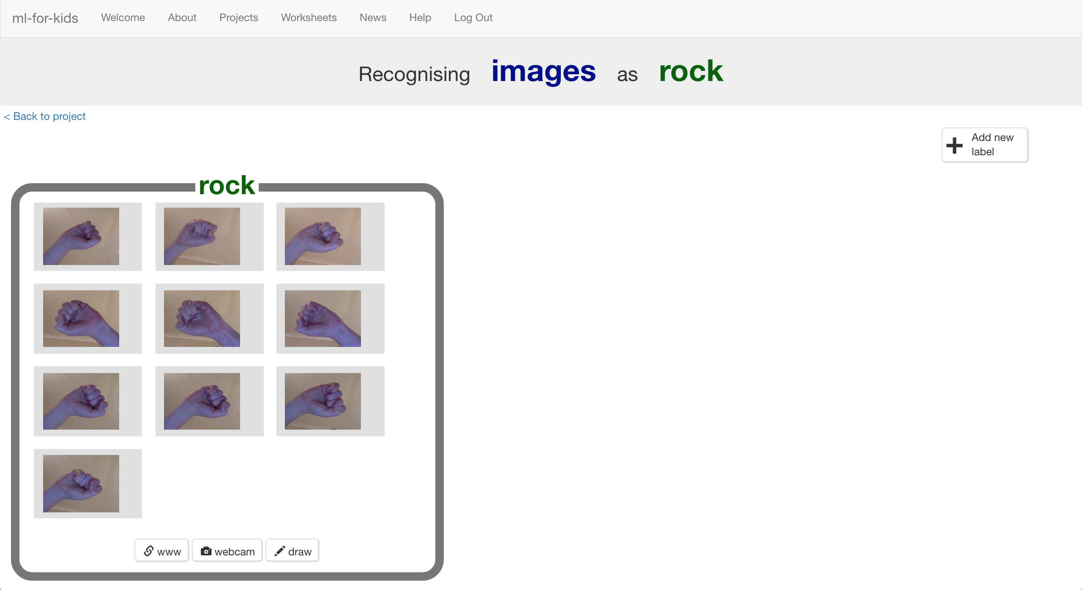
5. Click “**+ Add new label**” and create one called “paper”  
   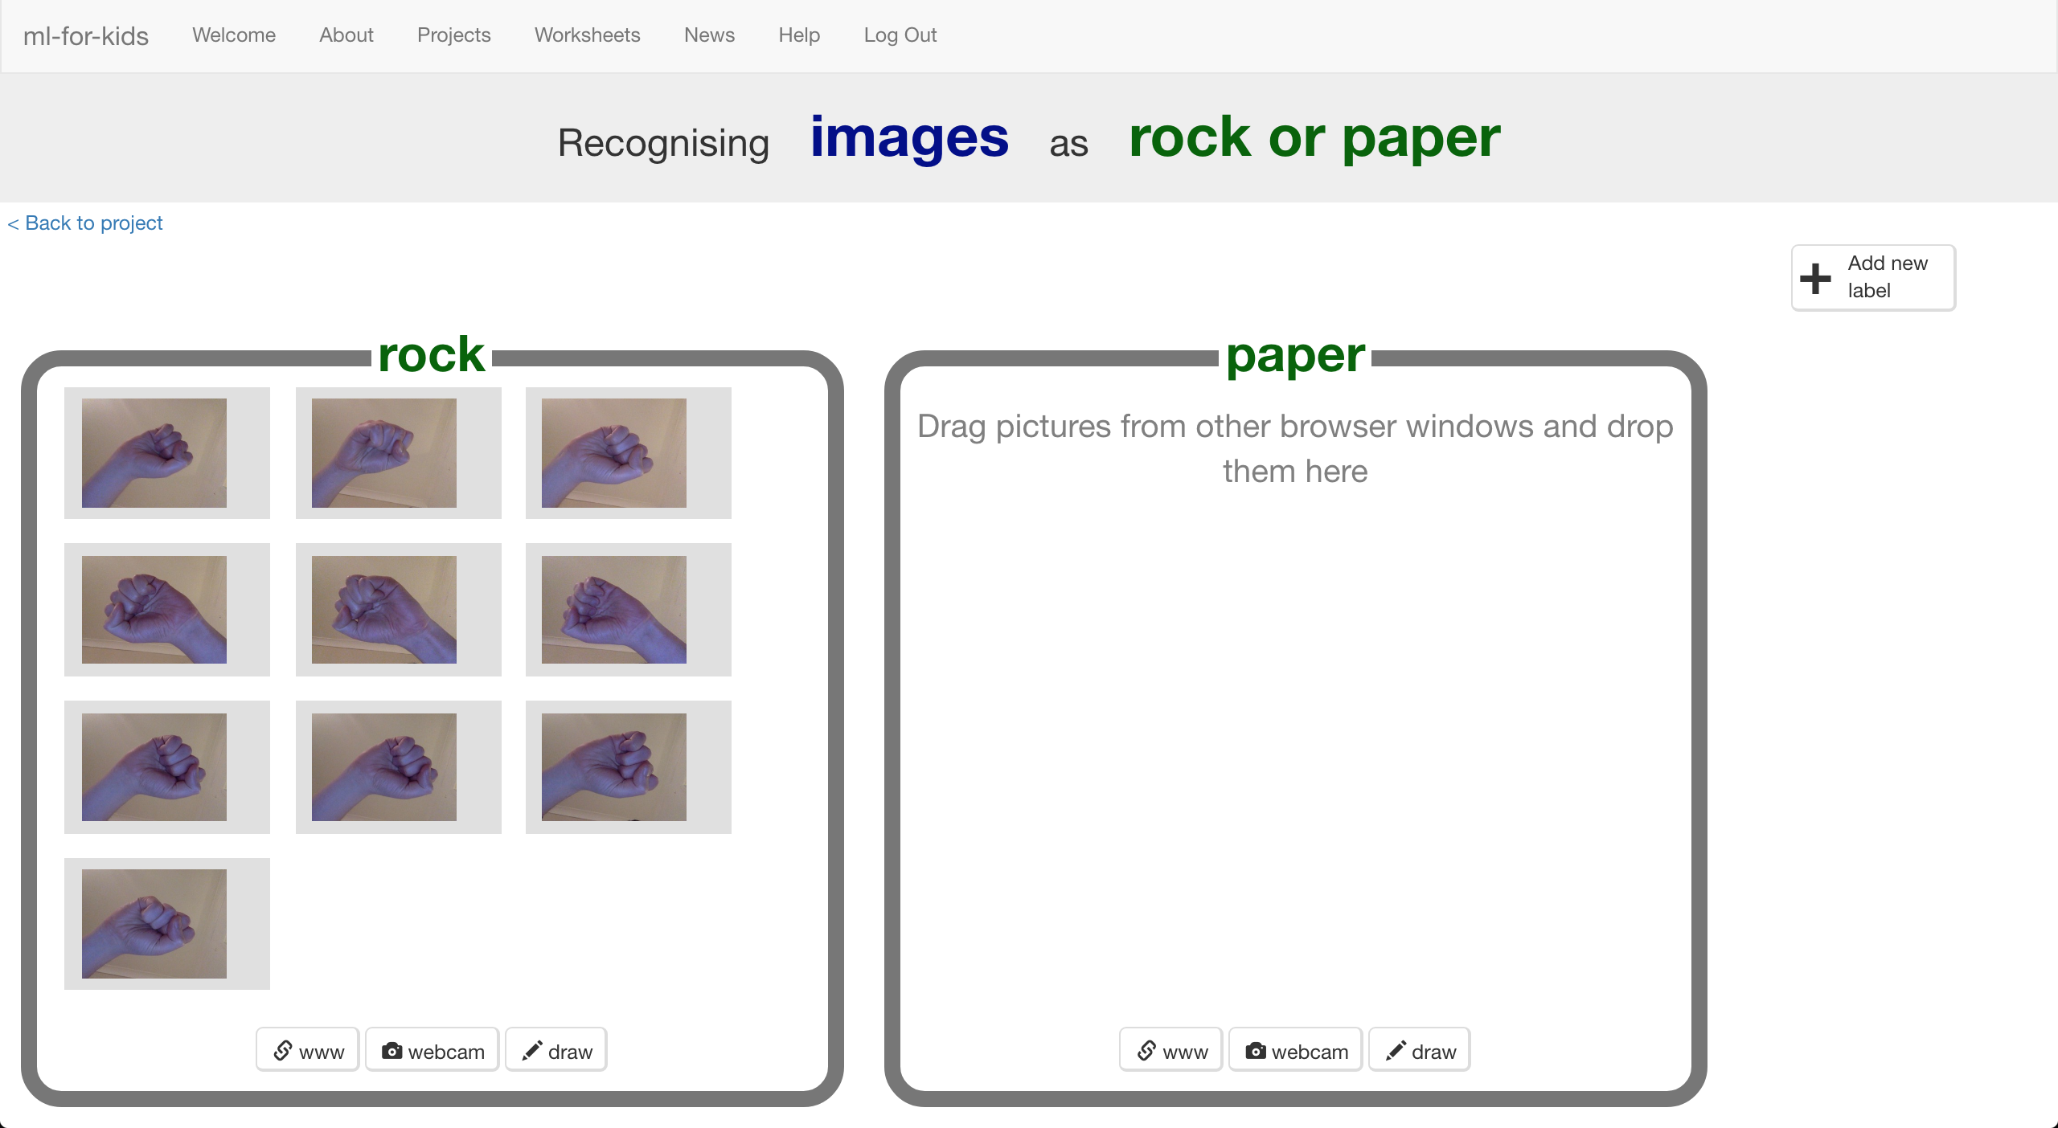
6. Click the “**webcam**” button in the “paper” bucket
7. Click “**ADD**” for a photo of your hand in a “paper” shape (flat hand)
8. Repeat until you have **10** photos of your hand in a “paper” shape *Try to get a variety of positions, angles and sizes.  
   The more variation the computer has to learn from, the better.*  
   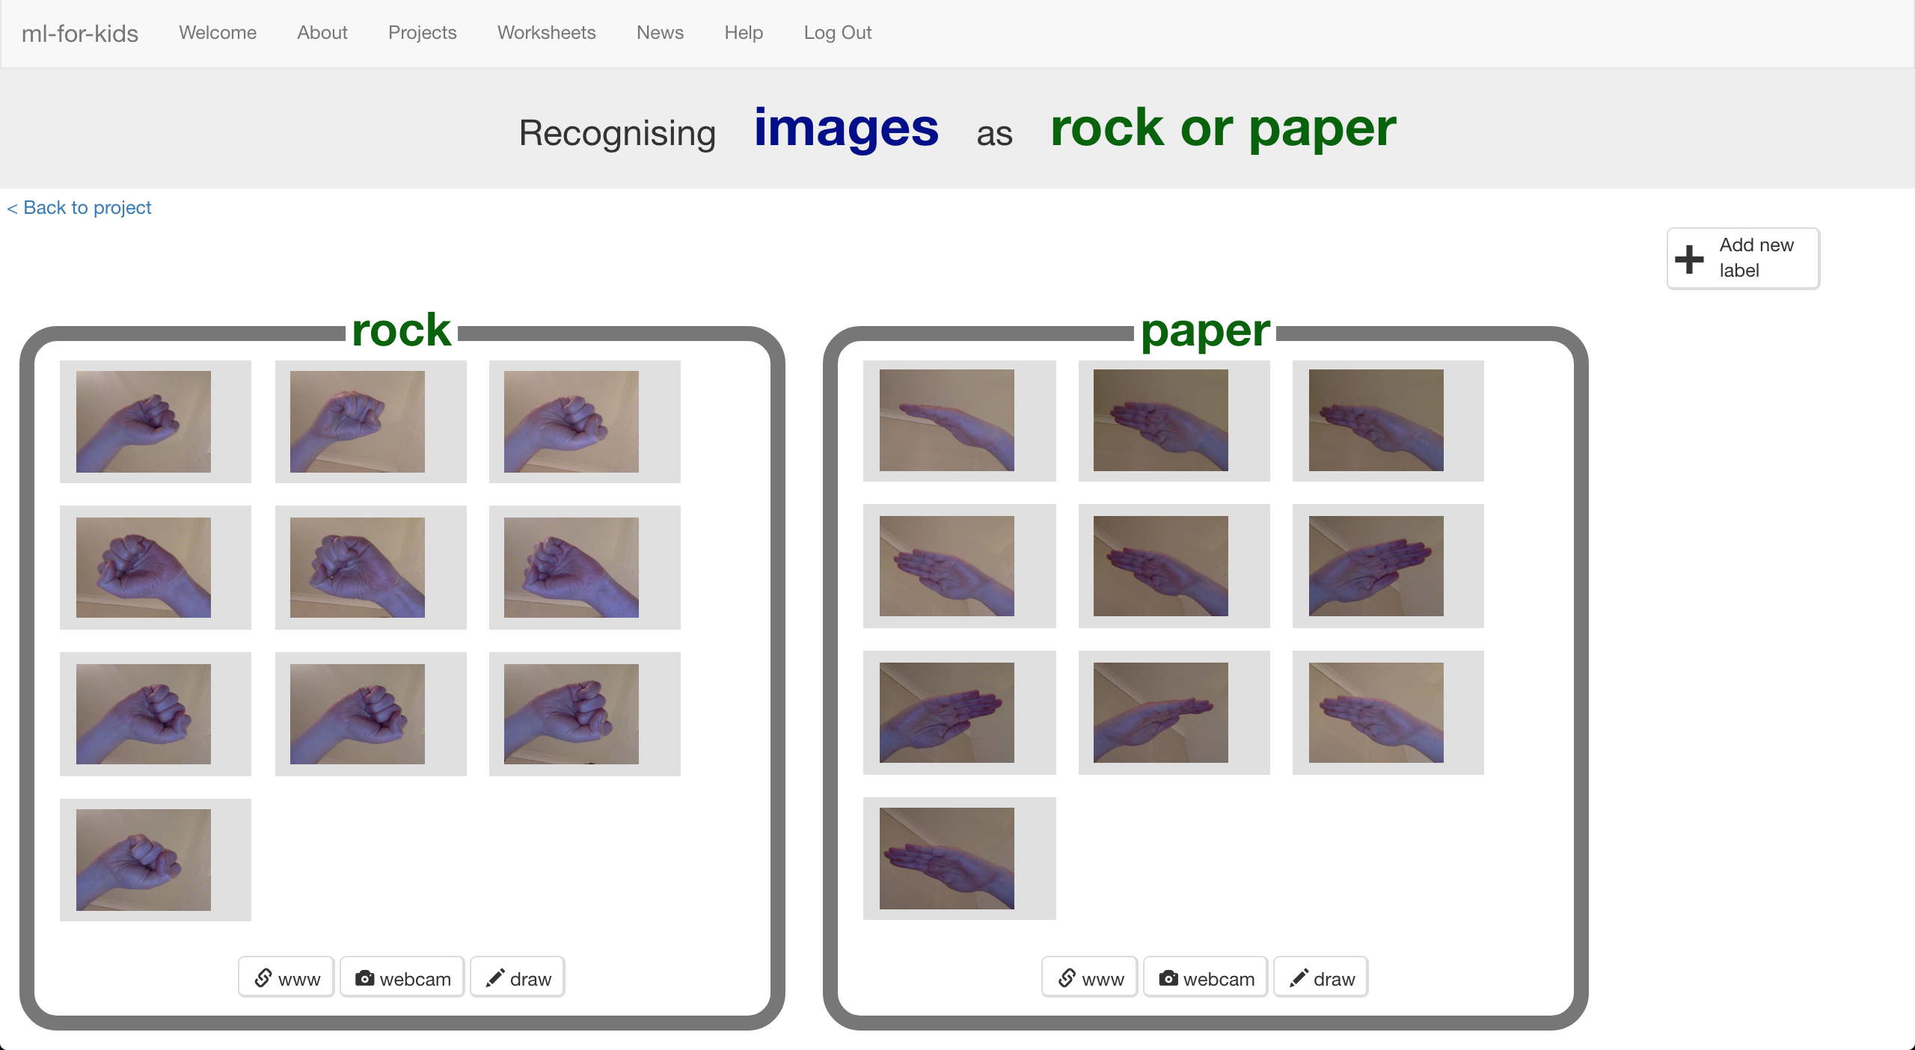
9. Click “**+ Add new label**” and create one called “scissors”
10. Use the “**webcam**” button in the “scissors” bucket to take **10** photos of your hand in a “scissors” shape (two fingers).  
    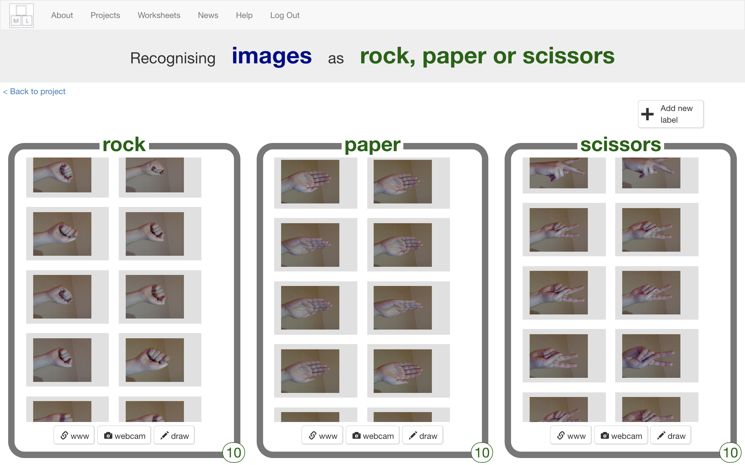
11. Click the “**< Back to project**” link.
12. Click the “**Learn & Test**” button.
13. Click the “**Train new machine learning model**” button.   
    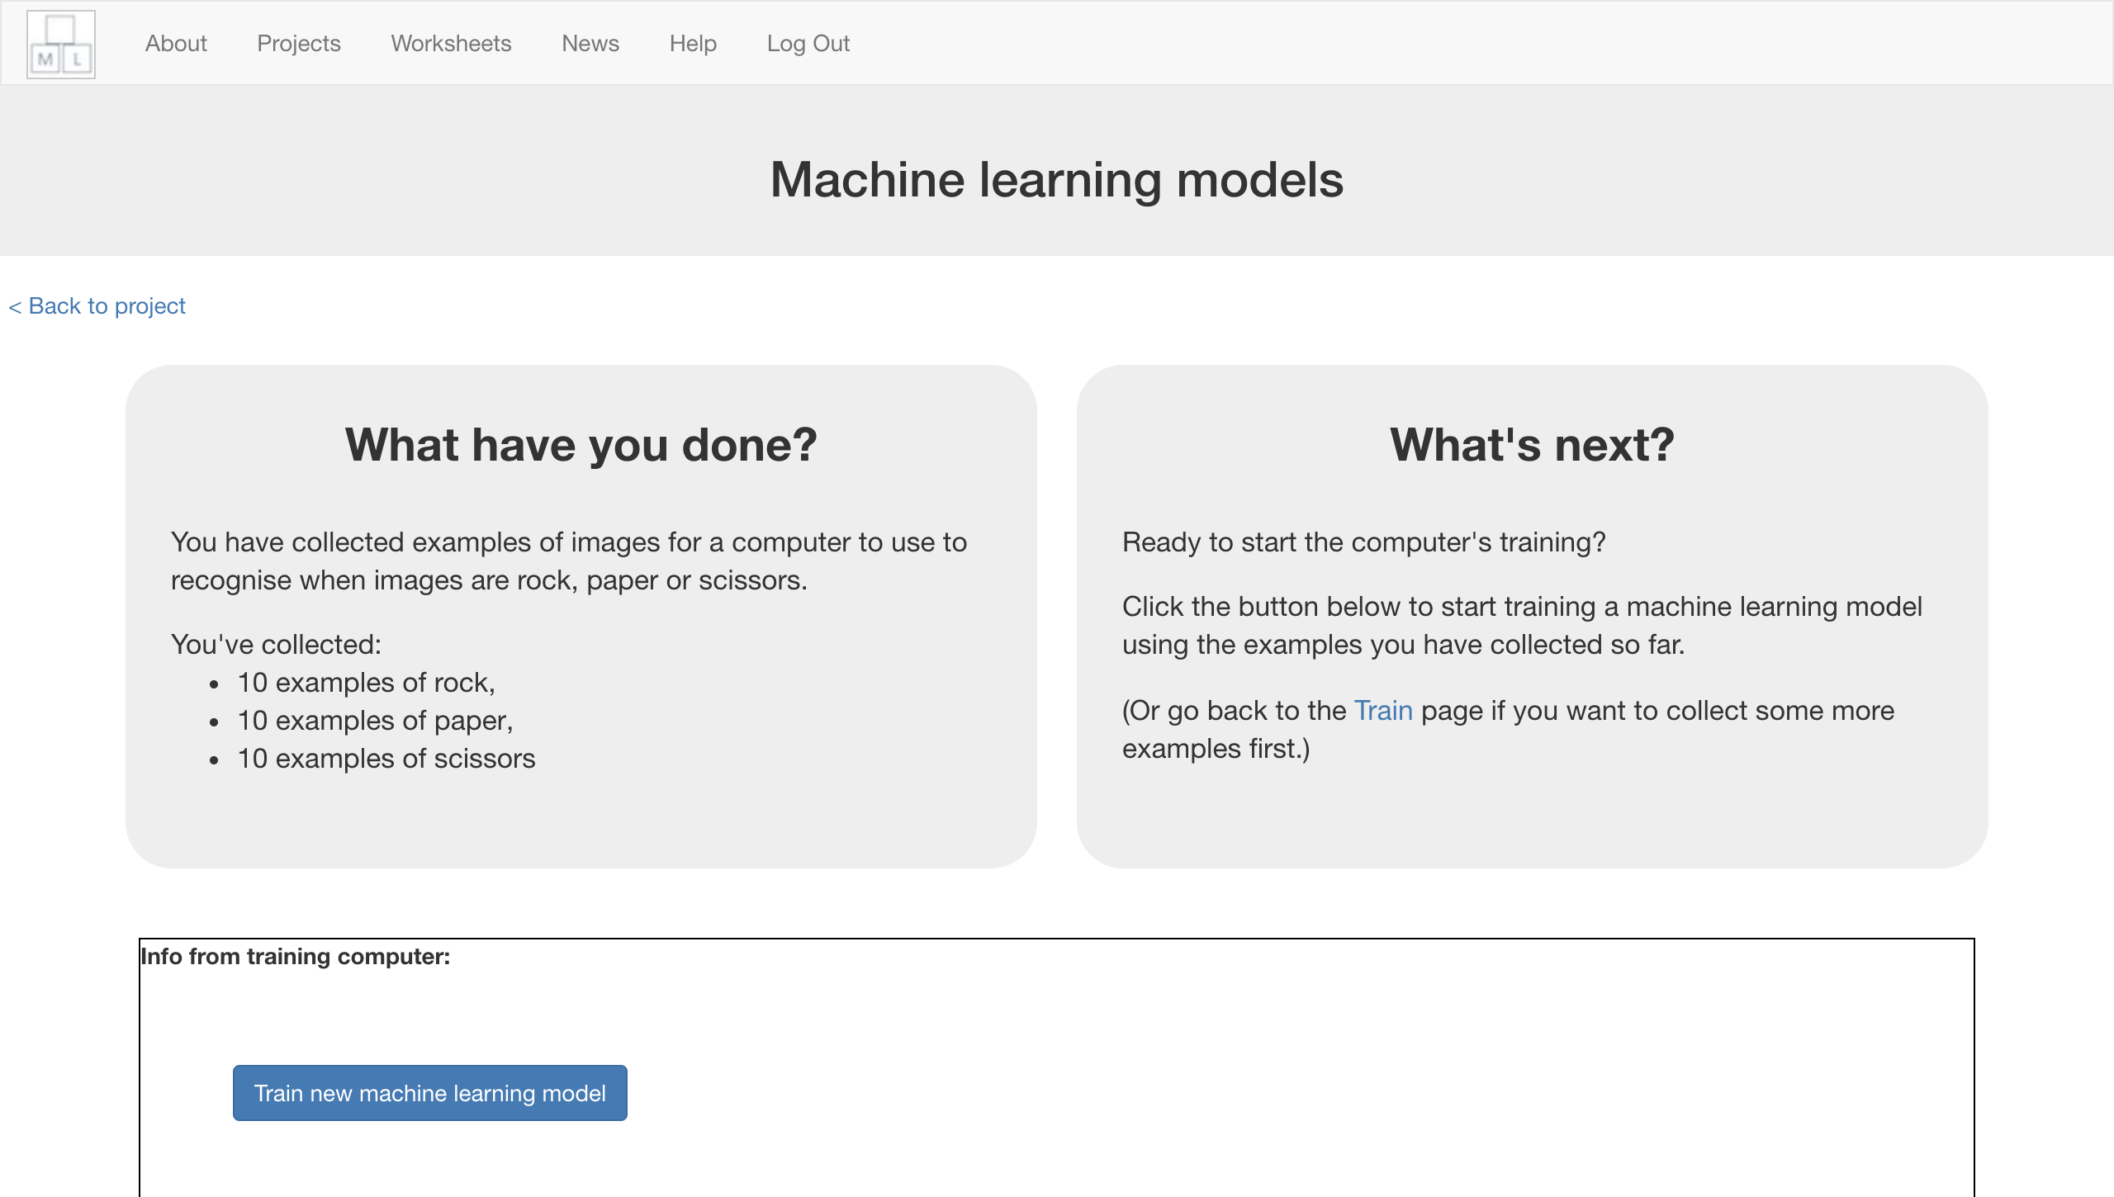
14. Wait for the training to complete. This might take a few minutes.  
    *While waiting, try the multi-choice quiz at the bottom of the page.*
15. Click “**< Back to project**”

**What have you done so far?**

You’ve started to train a computer to recognise pictures as being rock, paper or scissors. You are doing it by collecting example photos. These examples are being used to train a machine learning “model”.

This is called “supervised learning” because of the way you are supervising the computer’s training.

The computer will learn from patterns in the colours and shapes from each of the photos you’ve given it. These will be used to be able to recognise new photos.

**Tips**

**More examples!**

The more examples you give it, the better the computer should get at recognising whether a photo of your hand is rock, paper or scissors.

**Try and be even**

Try and come up with roughly the same number of examples for each shape.

If you have a lot of examples for one type, and not the other, the computer might learn that type is more likely, so you’ll affect the way that it learns to recognise photos.

**Mix things up with your examples**

Try to come up with lots of different types of examples.

For example, you could include examples of your hand coming from the left side of the photo as well as examples of your hand coming from the right side.

Some could look small (with your hand further away) and some could be larger (with your hand very close).

1. Click the “**Make**” button
2. Click “**Scratch 3**”  
   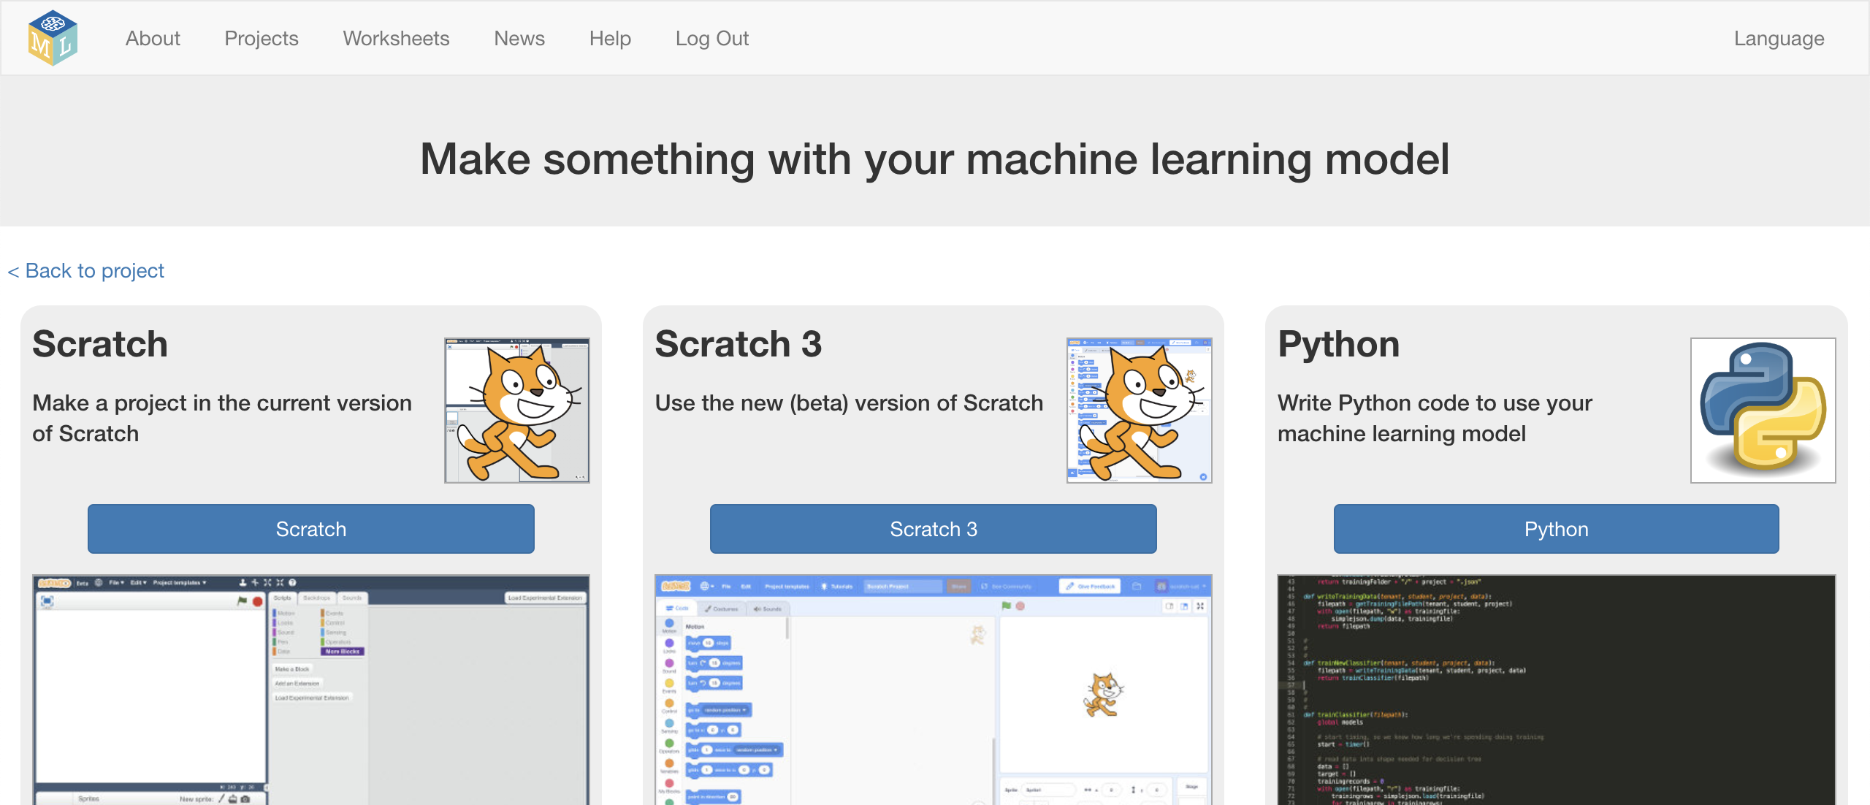
3. Click “**Open in Scratch**”
4. Click on “**Project templates**”  
   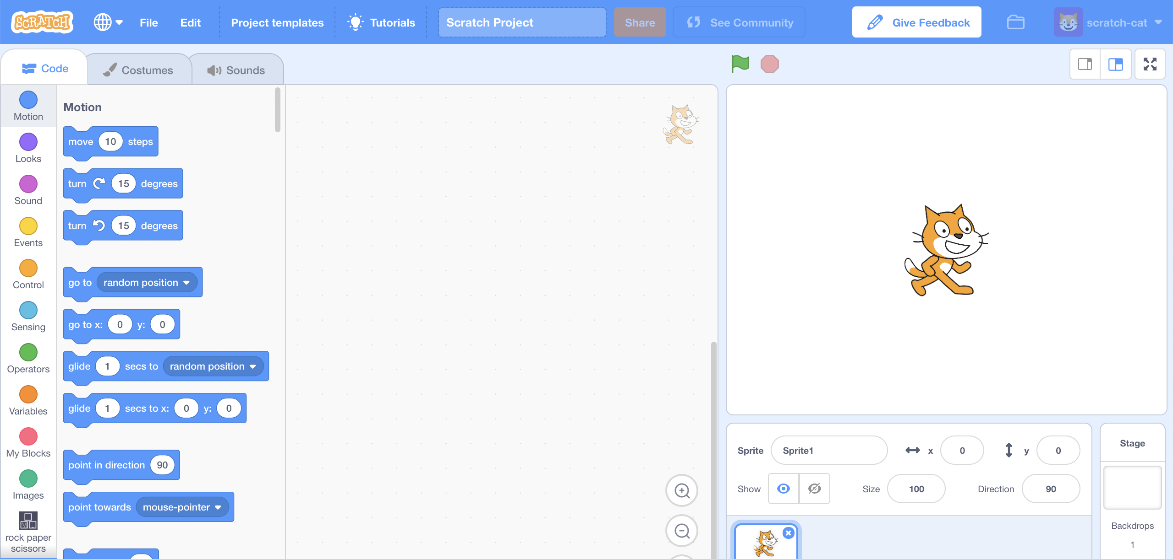
5. Click on the “**Rock Paper Scissors**” project template.   
   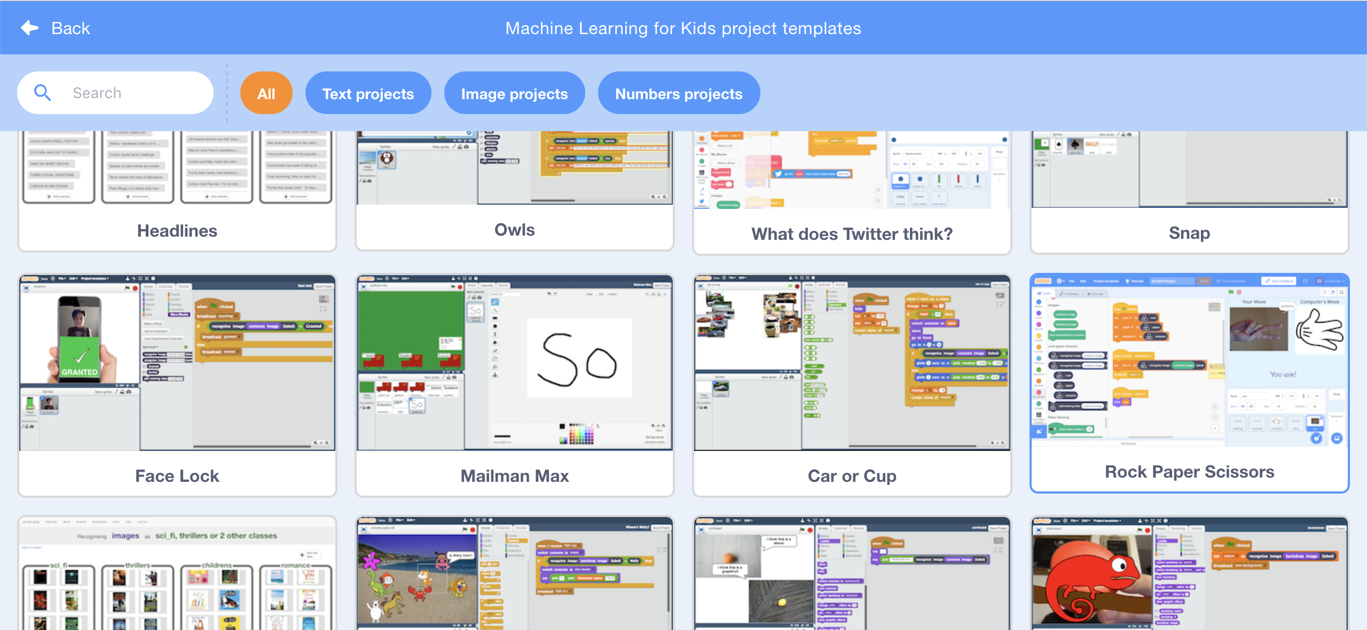
6. Click on the “**you**” sprite.  
   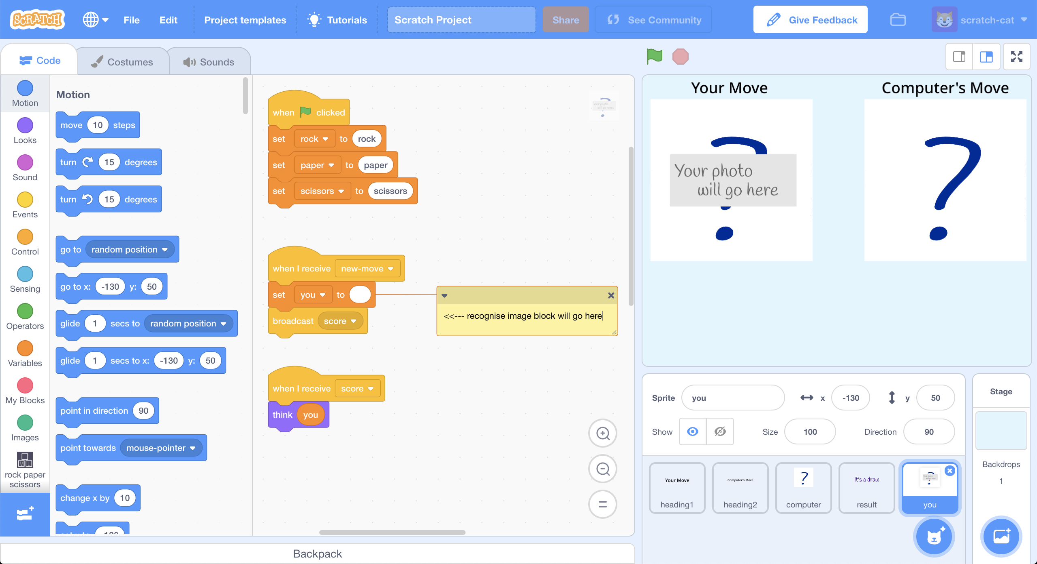
7. Update the **green-flag-clicked script** by adding your project blocks  
   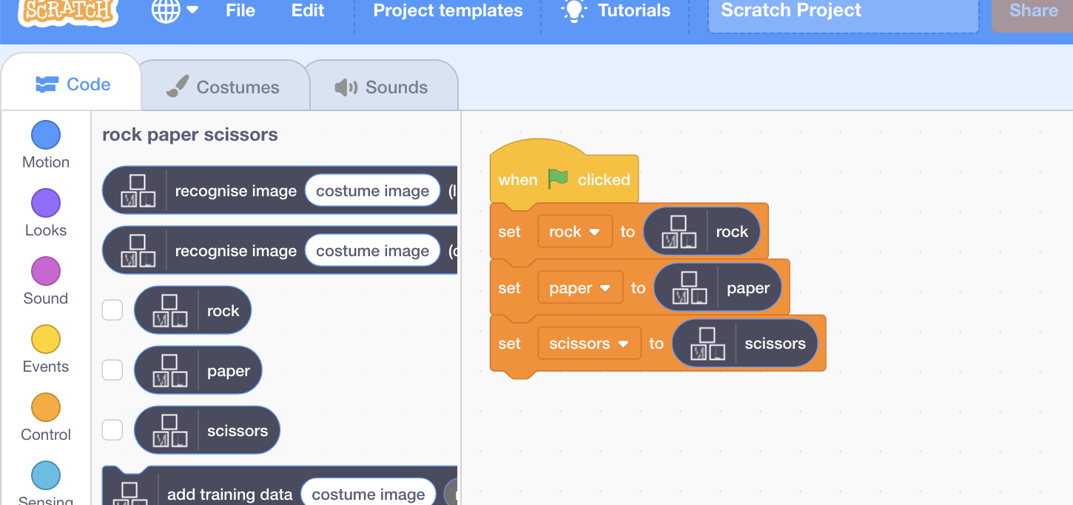
8. Update the **new-move script**   
   *Add the “****recognise image****” and “****costume image****” blocks*  
   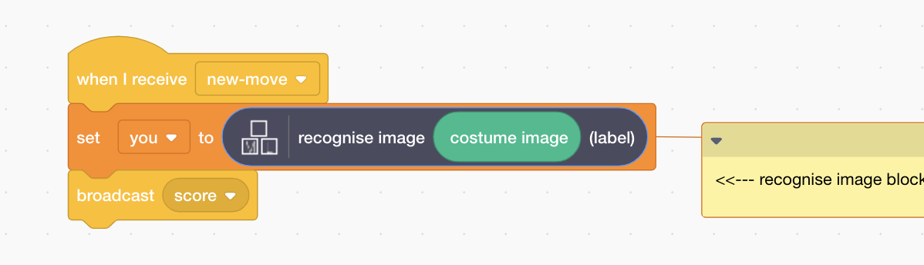
9. Test your project  
   *Click the* ***Green Flag****, then click press the “P” button to take a photo.*

*The computer will choose a random picture.   
It will try to recognise your hand shape, and then display who won.   
*

1. If the computer is not very good at recognising your hand shapes, go back to step 21, and add more examples for the computer to learn from.   
   You’ll need to repeat step 24 and train a new machine learning model after you’ve added more examples.

**What have you done?**

You’ve made a simple rock-paper-scissors game in Scratch.

The game uses a webcam to take pictures of your hand, and uses machine learning to understand the meaning of the photo.

This is “image recognition” – teaching a computer to recognise images.

For a more advanced way of making a project like this, try the “Hand Gestures” worksheet next.